# Essex Labor Day 2025 Food Vendor Permit Request

**Organization/Business/Event:**

**Contact Person(s): Address:**

**E-Mail:**

**Telephone #:** **Cell Phone #:**

**Fees: Per Day All 3 Days**

(Sat, Sun, Mon)

Commercial Businesses $90/day $200

(if you desire to have your operation hours listed on our schedule – you must be an ECC Sponsor with annual dues paid by July 1st)

ECC Sponsor Members** (***) $45 $100

* Local Non-Profit Groups that are members of the Essex Community Club.

** If you are not sure if you are an ECC Sponsor Member or if you would like to become a member, please call our office.

*** This is for commercial businesses that generate a profit from their event, this DOES NOT include non-for-profit organizations. ECC Sponsorship Dues must be paid by July 1st to be eligible for complimentary permit.

**Serving Dates Requested:** Please indicate the days you would like to serve. This will be published on our schedule so provide accurate information.

Saturday Time: to

Sunday Time: to

Monday Time: to

**Dimensions of your booth/trailer**  feet (front) x feet (side).

**Please Check One:** Yes, we need electrical outlets at volt. Cost is $10 per day/$30 for the weekend.

No, we do not need an electrical connection.

***Electrical outlets are limited and cannot be guaranteed available, please consider alternate power resources. First Pay / First Serve Basis***

**Menu:** *To avoid duplication, please list the food and beverage items you plan to sell*. If too many vendors request to serve the same foods, we may ask you to adjust your menu. Vendors will be listed on advertisement (similar to listing on EssexIowa.com schedule) but are encouraged to advertise their specific event and menu if desired. You will NOT be able to add items to your menu once you check in at the park.

**Food/Beverage # of Items Estimated Price**

|  |  |  |
| --- | --- | --- |
|  |  |  |
|  |  |  |
|  |  |  |
|  |  |  |
|  |  |  |
|  |  |  |
|  |  |  |
|  |  |  |
|  |  |  |

***Please read details on the back of this form and return with your proper fee.***

**Rules & Regulations:**

1. The City of Essex and Essex Community Club are not responsible for theft or damage to your property or merchandise. Please secure your items &/or maintain personnel at your booth.
2. Permits accepted are not eligible for refunds, if you later choose not to participate, the fees are considered a donation to the Essex Community Club.
3. Intent to participate must be declared by July 1 with payment in full by July 30. Permits received and accepted prior to July 1 will be included in promotional flyers and publications. Those received afterward will be subject to additional fees set forth in the Labor Day Late Vendor Policy.
4. Only activities that are listed on the permit are permitted during the scheduled event.
5. Events are to be carried out to promote a positive image of the Organization or Business, the Essex Community Club and City of Essex. The event chairs/coordinators will work with the Labor Day Chair and committee to make an ALL-AROUND successful Celebration and not just their event.
6. This set of rules follows the Essex City Ordinance.
7. All vendors/events will set up stands in locations determined by the Essex Community Club

***and all food vendors must carry liability insurance and comply with the Iowa Department of Revenue rules governing sale of food for consumption on the premise.*** Proof of insurance must accompany permit application and are not accepted until all required paperwork is submitted.

1. The City of Essex does not provide electrical hook ups or utilities for street vendors. You are required to provide these services for your booth if necessary.

Please send both pages of your permit request to: Essex Community Club

c/o Labor Day Vendor Permits

P.O. Box 334

Essex, Iowa 51638

Questions? Please call Jena Bowers at (712) 215-5472 or e-mail [3jscraftshed@gmail.com.](mailto:3jscraftshed@gmail.com)

[She will call or e-mail](mailto:laborday@essexiowa.com) you confirmation upon receipt and acceptance of request.

**Agreement:**

I/we understand the rules and regulations according to the Essex Labor Day celebration. Signature Date

**Fee Enclosed:** Venmo available @essexcommunityclub

* * * * * * * * * *

**For Office Use:**

This permit has been reviewed and accepted.

Approximate booth/event location will be:

Labor Day Chair Date Accepted

## PERSONNEL

* All employees, including volunteers, shall be under the direction of a designated person in charge at all times of operation.
* The person in charge shall ensure that all food handlers are following the Temporary Food Stand Requirements.
* Every employee and volunteer must sign a logbook with their name, address, telephone number, and the date and hours worked. This logbook must be maintained by the person in charge for 30 days.
* All food handlers shall be free of contagious or communicable diseases, sores, or infected wounds; must keep themselves and their clothing clean; and must keep their hair properly restrained.
* Tobacco use of any kind is not permitted inside the stand or while attending grills outside the stand.
* No eating or drinking is allowed in food preparation areas.
* Personal belongings shall be stored in a designated place adequately separated from food, food contact surfaces, and dishwashing areas.

## ILL FOOD HANDLERS

* Cover lesions on the hands or wrist with an impermeable finger cot or stall and with a single- use glove.
* Exclude employees with a diagnosed foodborne illness (such as Norovirus, Salmonella, Shigella, E. coli 0157:H7 or Hepatitis A) or sudden onset of vomiting or diarrhea, from the establishment.
* Exclude or Restrict employees from working with exposed food or clean equipment, utensils, linen, and unwrapped single service and single-use articles when the following symptoms are present:
  1. Vomiting
  2. Diarrhea
* 3) Jaundice

4) Sore throat with fever 5) Open/draining lesions

## **GOOD HYGIENIC PRACTICES AND TEMPERATURE CONTROL ARE OF EXTREME IMPORTANCE TO PREVENT FOODBORNE ILLNESS!

**FOOD PREPARATION AND FOOD HANDLING**

* Bare hand contact with ready-to-eat food is prohibited. Food handlers should

limit direct hand contact with all foods as much as possible with the use of tongs, deli tissues, gloves, and other utensils.

* All food preparation and contact surfaces must be of a safe design with durable, smooth, and easily- cleanable surfaces.
* Food must be thawed, reheated, and cooled using procedures approved in the Food Code.

## FOOD AND CONDIMENT DISPLAY

* Condiment stations must be in an area where they may be constantly monitored.
* All foods on display shall be covered or individually packaged and meet appropriate temperature requirements.
* All food must be protected from customer handling, coughing or sneezing, and other contamination by wrapping, sneeze guards, or other effective means.
* The public is not allowed to serve itself from opened and uncovered containers of food.
* Sugar, ketchup, mustard, and other condiments must be individually packaged or dispensed from closed squeeze, pour, or pump type dispensers.

## COOKING AND STORAGE TEMPERATURES

All potentially hazardous foods shall be refrigerated at 41°F or less or held at 135°F or higher. All cooling units must be equipped with an accurate, easily visible thermometer. An accurate metal stem food thermometer must be provided to check storage and cooking temperatures. Cooking temperatures for meat products and reheating must be as follows:

Poultry and Ground Poultry All other Ground Meat Pork or Fish

Whole Muscle Beef

Reheated or microwaved items for Hot Holding Properly Cooked Foods Hot Holding Cold Holding

**\*If raw or undercooked animal foods such as meat, eggs, or fish are served, required by the Food Code must be conspicuously posted or included in the**

165°F

155°F

145°F

145°F

165°F

# Proper Refrigerated Storage

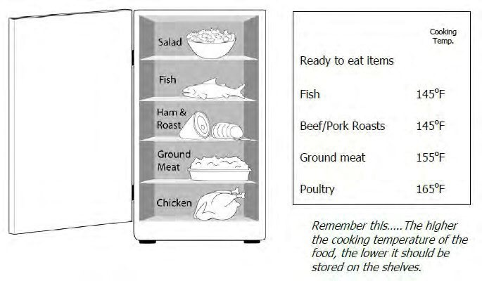

## THERMOMETERS

* Thin tip probe thermometers are required to monitor food cooking and holding temperatures.

## COOKING, PREPARATION AND SERVICE UTENSILS

* All equipment and cooking utensils must be maintained in a sanitary manner.
* A three-compartment operation may be required for washing, rinsing and sanitizing. This requirement may be waived depending on the menu and the number of utensils being utilized by the operator.

## EATING AND DRINKING UTENSILS

* Use disposable single-service plates, cups and utensils.
* If approved, reusable eating or drinking utensils (such as commemorative cups) must be washed, rinsed, sanitized and air dried using clean hot water and three basins large enough for immersion of the dishes prior to re-filling.

## FOOD AND FOOD CONTACT ITEM STORAGE

* All food supplies and food contact items shall be stored off the ground and shall be properly covered to be protected from dust, rain or other contamination.
* Potentially hazardous foods must meet temperature requirements as previously stated.
* Leftover cooked food must be discarded at the end of each day and cannot be reused.

## WAREWASHING, SANITIZERS AND WIPING CLOTHS

* + Chlorine bleach or another approved sanitizer shall be provided for ware washing and wiping cloths.
  + Wiping cloths shall be provided for wiping counters, tables, and other food contact surfaces. Cloths shall be rinsed frequently and stored in a clean sanitizer solution between uses.
  + Sanitizing solutions shall be of an appropriate concentration. Chlorine sanitizer should be mixed to 50ppm-100ppm, quaternary ammonium sanitizers should be mixed to 200ppm or as specified on manufacturer’s instructions. All other sanitizers must be mixed to manufacturer’s specifications.
  + Test strips are required for checking sanitizer levels.
  + Sanitizing solution shall be changed as needed to maintain the solution in a clean condition.

**WAREWASHING (utensil washing)**

* + Three 5-gallon (minimum) containers of water large enough to fit largest utensil.
  + First container should contain soapy water for washing. Second container should contain fresh clean water for rinsing. Third container should contain a sanitizer & water solution for sanitizing.
  + Container contents shall be changed as needed to maintain the water and solutions in a clean condition.
  + Allow utensils to thoroughly air dry prior to storage or re-using.

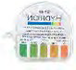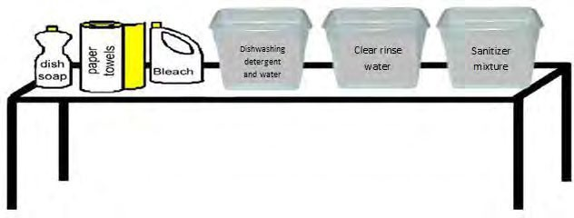

# HANDWASHING

## *HANDWASHING STATIONS AND SANITIZER BUCKETS WITH WIPING CLOTHS MUST BE SET UP AND USED PRIOR TO ANY FOOD HANDLING, PREPARATION, OR SALES.

Hands must be washed at the designated handwashing station as frequently as necessary to maintain good sanitation. Always wash hands before beginning work and after going to the restroom, eating, taking breaks, handling garbage, handling raw meat, or using tobacco products.

## HANDWASHING STATION REQUIREMENTS

* 1. An accessible and functional handwashing sink or set-up shall be provided within the perimeter of every business selling, serving, or providing food or beverages. Grill areas that are separate from other food handling areas should have a separate handwashing station. If only pre-packaged food products are sold, handwashing facilities are not required, i.e., canned pop, boxed candy, packaged snack foods.
  2. Handwashing facilities shall not be used for the cleaning of equipment, storage of wiping cloths, or the disposal of liquid waste.
  3. All food products, cooking equipment and serving utensils shall be protected from splash or spillage caused by handwashing.
  4. Disposable paper towels shall be provided with each handwashing facility and will be properly disposed of after being used.
  5. Any one of the following set-ups can be used as a handwashing facility in a temporary stand setup:
     1. Portable commercial hand sinks that produce water flow within 10 seconds of activating a hand pump or opening a dispensing valve. Soap from a sanitary dispenser and paper towels shall be provided.
     2. Minimum of **2 gallons per person (every 4 hours)** of potable water will be maintained in a container, or containers, capable of dispensing water through a valve or spout. This valve or spout shall enable a constant flow of water when opened. The wastewater shall be collected in another container and disposed of in a sanitary sewer. Soap from a sanitary dispenser and paper towels shall be provided.
  6. An accessible hand sink shall accompany any toilet utilized by food handlers. Soap from a sanitary dispenser and disposable single-use towels shall be provided. The sink shall be used for handwashing only. Handwashing facilities shall be checked regularly for adequate soap, towels, and water

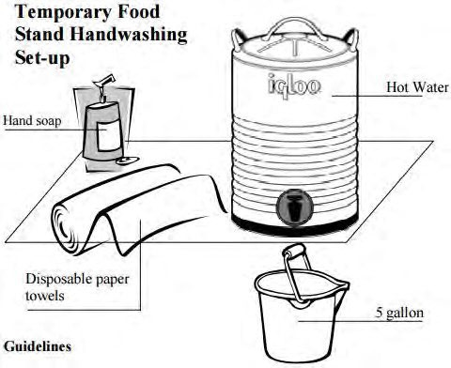

# WASTEWATER AND GARBAGE DISPOSAL

* Wastewater must be disposed of in an approved manner.
* Water or melting ice shall not create a wet or muddy area around the stand.
* An adequate number of covered trash containers shall be provided at each stand.
* It shall be the responsibility of the food stand operator to keep the area around their stand free of food scraps, paper, and other trash.

# STAND CONSTRUCTION

* Stands shall be constructed to include overhead shelter to protect food.
* If required, side screening shall be provided to protect from insects, dust, and weather.
* If required, floors shall be constructed of wood, asphalt, rubber or plastic matting to control dust, mud, and insects.
* Adequate lighting shall be provided, and lights above exposed food preparation areas must be shielded or shatterproof.

# OPERATING A TEMPORARY FOOD STAND WITHOUT A LICENSE

* A Temporary Food License must be obtained prior to set up and serving, selling, or providing food at a temporary event.
* Food vendors that are operating without proper licensure will be required to stop serving food while a temporary food license application is filled out and an inspection is conducted at the food stand.
* A double license fee will be collected for each food stand operating without an appropriate license.
* Mobile Food Units operating outside the scope and requirements of their license will be required to cease operating. They will have the option to fill out a Temporary Food License application and pay a double fee for operating without an appropriate license.

# QUESTIONS

For questions- contact your Regulatory Authority

Click for: Additional Regulatory Requirements for Temporary Food Establishment’s Or visit our website: https://dia.iowa.gov/